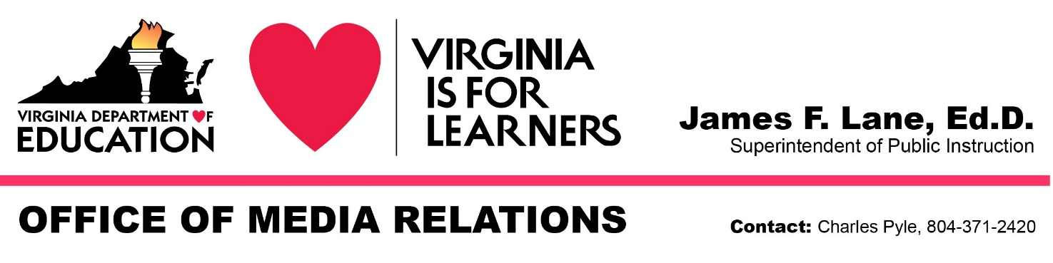
For Immediate Release: February 9, 2021

State Superintendent Announces Virginia LEARNS Workgroup to Guide Reopening and Recovery

RICHMOND — Superintendent of Public Instruction James Lane today announced the formation of a workgroup of educators, school administrators, mental health professionals, parents and leaders of community organizations to assess the needs of students and support Virginia school divisions as they implement Governor Ralph Northam's directive to provide in-person instruction options for students by March 15.

Using the Virginia Department of Education’s Recover, Redesign, Restart 2020 guidance document as its starting point, the Virginia LEARNS (Leading, Engaging, Assessing, Recovering, Nurturing and Succeeding) workgroup will develop recommendations and identify resources and best practices related to equity, curricula — especially in literacy and mathematics — remediation and intervention strategies, assessments, data analysis, and technology to support instruction.

Lane also charged the workgroup with creating and identifying resources and best practices to address the impact of the coronavirus pandemic on the mental health and social-emotional well-being of students, families and school employees.

“I want to thank the members of the Virginia LEARNS workgroup for accepting the challenge of helping the commonwealth’s public schools navigate these extraordinary circumstances and meet the needs of students, especially those who have fallen behind while their schools have been unable to provide in-person instruction and support services,” Lane said. “The workgroup will assist school divisions — regardless of their current status — chart a course for the remainder of the current school year, this summer and into 2021-2022.”

Charlottesville Superintendent Rosa Atkins will serve as chair of the Virginia LEARNS workgroup. Smyth County Superintendent Dennis Carter, Franklin County Superintendent Bernice Cobbs, Chesapeake Superintendent Jared Cotton and Newport News Public Schools Chief of Staff Rashard Wright will also serve in leadership roles. The other members are as follows:
- James Angelo, assistant superintendent for instruction, Frederick County Public Schools
- Roxana Bandes-Muldoon, director, Office of Equity and Accountability, Stafford County Public Schools
- Kathy Burcher, deputy secretary of education, Office of the Governor
- Michelle Cottrell-Williams, 2018 Virginia Teacher of the Year, Arlington County Public Schools
- Pamela Brandon Croom, president-elect, Virginia PTA
- Pamela Davis-Vaught, member, Virginia Board of Education; principal, Highland View Elementary, Bristol Public Schools
- Lisa Dolan, lead school social worker, Spotsylvania County Public Schools
- James J. Fedderman, president, Virginia Education Association

(more)

- Timothy Healey, principal, Colgan High, Prince William County; president, Virginia Association of Secondary School Principals
- Carolyn Jackson, supervisor, Office of Equity and Excellence, Arlington County Public Schools
- Andrea Johnson, 2020 Virginia Teacher of the Year, Salem Public Schools
- Ernest Longworth, director of instructional innovation, Chesterfield County Public Schools
- Kassie Myers, elementary school counselor, Halifax County Public Schools
- Hayley Poland, assistant superintendent of equity and student services, Roanoke Public Schools
- Abigail Farris Rogers, president, YMCA of Greater Richmond
- Laura Saunders, instructional supervisor, Augusta County Public Schools
- Emily Solari, professor of reading education, School of Education and Human Development, University of Virginia
- Jennifer Suh, professor of mathematics education, George Mason University
- Sarah Summers, school psychologist, Gloucester County Public Schools
- Anthony Swann, 2021 Virginia Teacher of the Year, Franklin County Public Schools; member, Virginia Board of Education
- Janet Turner-Giles, president, Virginia School Boards Association
- Deborah White, chief financial officer, Goochland County Public Schools
- Frances Wilson, director of technology and testing, Lunenburg County Public Schools

“The workgroup members bring a diverse set of perspectives and experiences to the table,” Lane said. “All regions of the commonwealth are represented. There are members from urban, rural and suburban divisions. And there are representatives of school divisions that have safely provided in-person instruction during most or all of the current school year while overcoming the challenges of COVID-19.”

VDOE staff will support the Virginia LEARNS workgroup as it carries out its mission. The panel will conduct its first virtual meeting on Wednesday, February 17. The workgroup will then solicit input from various education stakeholder groups before producing a final report in late April.

# # #

